CULTURAL AFFAIRS
Covering the crossroads of culture and culture

CULTURAL AFFAIRS: Covering the crossroads of culture and culture
JANUARY 25, 2014, 5:59 PM

Treasures, Sales, And Macarons Mark The Opening of BRAFA 2014

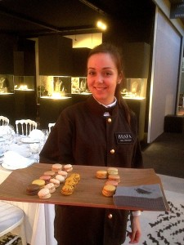
photo P. Madden
No fanfare. No celebrity sightseeing. No paparazzi. What you find, year after year at the BRAFA fair in Brussels, is elegance, intimacy, quality, and connoisseurship. (And a dazzling array of diamonds.) Much to my delight, if perhaps not to the organizers of the fair, BRAFA remains still something of a secret, largely localized (there are no American galleries among the 131 exhibitors here – not even, surprisingly, Barbara Gladstone, who even has a Brussels space). But those who know of BRAFA – and there are some 50,000 of us at this point – return as if to a reunion of sorts, especially during the three preview days, which echo with “bonjours” and the clinking of thousands of glasses of Champagne.
Part of the joy of BRAFA, which I have always described as a mini-Maastricht, is the wide diversity of art displayed here, from a Tom Wesselmann canvas and Damien Hirst spin-painting (Galerie Rive Gauche) and Ross Bleckner pantings (Maruani-Noirhomme) to a five-meter, 16th-century Flemish tapestry (Mullany), a mosaic sarcophagus fragment depicting a large bird from the 3rd century BC (Galerie Cybele), and a knockout Picasso nude on paper (Manuel Barbie). Particularly strong are the sections for tribal art and classical antiquities, the presence of which give dimension and context to the modern and contemporary works, as well as to the offerings in design and decorative art: suddenly the universe of art, and its history from the beginning of time, takes a coherent, tangible shape.
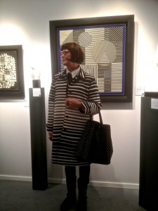
photo P. Madden
True, the same range characterizes the TEFAF fair,internationally acclaimed as the best art fair in the world as far as quality and breadth of material go; but walking through TEFAF can literally take days. The thread of continuity, the meditation, is lost. It is Just Too Big – more a marketplace (and after all, that’s what an art fair is, in the end) than an art experience.
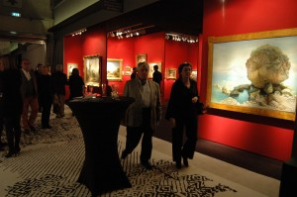
Brafa, 2014 (photo P. Madden)
Whether collectors view it this way, I can’t say; but sales during BRAFA’s first two VIP previews were quite brisk, in any event; and while the fair emphasizes non-contemporary art, it seems that modern and contemporary sold well, too, from the outset: severalSam Francis works on paper were snapped up within the early hours of the first preview at the stall of Harold t’Kind de Roodenbeke, BRAFA’s president; two Ensors found new homes quickly at Galerie Seghers; and the stall of Galerie Guy Pieters felt something like the art version of WalMart on Black Friday, with collectors nearly running over each other to claim small Bernard Venet sculptures, a series of drawings for Christo’s revitalized Abu Dhabi oil drum project, and more.
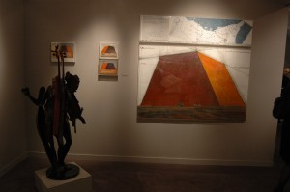
Guy Pieters' booth, Brafa 2014 (photo P. Madden)
Elsewhere, Canadian tribal art dealer Jacques Germain described the first days as “a very good start,” predicting “a successful year here,” while at Didier Claes, I counted about 15 red dots marking his extraordinary offerings of mostly Central African pieces, dramatically displayed alongside paintings by Antonio Baura. (One major item, a cordophone, or arched harp, was actually sold just prior to the fair; but with brisk sales during the first two preview events, by the evening of preview day three, there was almost nothing left at the stand for anyone to buy.)
Other treasures on view – some still available as of this writing, some not – include a lovely, early Gauguin drawing at Galerie Fleury (who also are offering an eye-catching hot pink and gold painting by Yayoi Kusama for a reasonable €49,000); a tender, but simple Giacometti sketch at Trigano (€50,000); a real, honest-to-god, faience “William the hippo” (William’s brother, perhaps? ) from about 1960-1860 BC at Harmakhis — which can be yours for just €400,000. One super showstopper especially grabbed my attention at Galerie Mermoz: a gently but intricately-carved Mayan conch shell ornament depicting an ancestor in feathered headdress. Astounding in its craftsmanship, with a serpents head and the headdress entirely integrated into the form of the shell itself, it is one of very few known examples of such pieces, according to the gallery, and perhaps the only one of this quality.
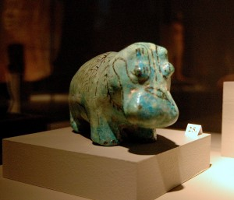
"William's brother" - Faience hippo at Galerie Harmakhis (photo P. Madden)
What was somewhat unfortunate was the decision by some dealers who plan also to attend TEFAF to hold back on their top pieces in anticipation of selling them in Maastricht. Note to dealers: No one will care if you bring something spectacular to BRAFA and show it at Maastricht, too. Collectors are neither naïve nor unforgiving: they know not everything will sell here. (Think of Otto Nauman and his headline-grabbing Rembrandt “Portrait of a Man With Arms Akimbo” on offer at TEFAF in 2012 at $47 million and which he ultimately offered in 2013 through Sotheby’s in Beijing.)
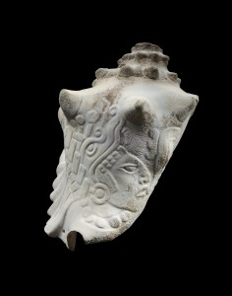
Mayan ornament, carved conch shell at Galerie Mermoz
Besides, as An-Jo Fermon of Whitford Gallery noted, “Belgian collectors on the whole are more motivated and knowledgeable than collectors I’ve met anywhere, and especially receptive to discovering things.” Via e-mail, Mullany’s Nicholas Mullany echoed her view: “Belgian collectors in our field have a true collectors’ cabinet mentality, are highly sophisticated, well read and appreciate quality and presentation,” he said. “They know what they are looking for and at, and are not swayed by fashion, fads or trends. For many, BRAFA is the focus point of their collecting year. It is one of the very best fairs in the world.”
Personally, I couldn’t agree more.
Tags: African art, ancient art, art fairs, BRAFA,Brussels, Christo, Epoque Fine Jewels, Kusama, pre-Columbian art, tribal art, Venet, William the Hippo

